**Project Based Learning Report on**

**Web Application to maintain Internship details**

Submitted to

Department of Computer Science and Engineering

Bachelor of Technology

in

Computer Science and Engineering

(2021– 2025)

**P. Baby Shiva Naga Sriya(21R11A0595)**

**K. Sri Vishnu Kshiraj(21R11A0581)**

Under the Guidance of

A. Sree Lakshmi (HOD CSE)



Department of Computer Science and Engineering

Accredited by NBA

**Geethanjali College of Engineering and Technology (UGC Autonomous)**

(Affiliated to J.N.T.U.H, Approved by AICTE, New Delhi)

Cheeryal (V), Keesara (M), Medchal.Dist.-501 301.

**August-2023**

**TABLE OF CONTENTS**

|  |  |  |
| --- | --- | --- |
| **S.No.** | **Index** | **Page No.** |
| **1** | **ABSTRACT** | **3** |
| **2** | **INTRODUCTION** | **4** |
| **3** | **OBJECTIVE** | **5** |
| **4** | **MODULES** | **6** |
| **5** | **OUTPUT** | **9** |
| **6** | **CONCLUSION** | **11** |
| **7** | **REFERENCES** | **12** |

1. **ABSTRACT**

In today's dynamic professional landscape, internships play a pivotal role in shaping the careers of aspiring individuals. Managing and coordinating internship programs efficiently is crucial for educational institutions and organizations alike. Our application streamlines administrative tasks, enhances communication, and fosters meaningful internship experiences for students. Our Web Application for Internship Details Management serves as a centralized platform for recording, organizing, and monitoring internship-related information.

1. **INTRODUCTION**

Internships are pivotal in a student’s professional development, they offer hands-on experience and real world insights into the market. To help manage these intricate tasks, we have developed a web application having the following features:

* **Student Information**: The application allows students to input and update student details, including their personal information, academic records, and contact information.
* **Document Management**: The system facilitates the submission and storage of internship-related documents, such as resumes, cover letters, and offer letters.
* **Progress Tracking**: Users can monitor the progress of internship applications, interviews, and onboarding processes, helping stakeholders stay informed and engaged.
* **Reporting and Analytics**: The application generates reports and analytics to offer insights into the effectiveness of internship programs, aiding in data-driven decision-making.

**3. OBJECTIVE**

Our web application the objectives we have set out , those objectives are:

* **Efficiency**: The primary objective is to streamline the management of internship details, making it easier for educational institutions and organizations to handle internships more efficiently.
* **Simplified Administration**: Simplify administrative tasks related to internships, reducing the workload and minimizing potential errors in managing internships.
* **Improved Communication**: Foster better communication among students, educational institutions.
* **Student Engagement**: Provide students with an easy-to-use platform for maintenance of their internship details.
* **Document Management**: Facilitate the submission and storage of necessary internship-related documents, making it easier for both students and administrators to manage paperwork.
* **Progress Tracking**: Enable the monitoring of internship application progress, interviews, and onboarding, ensuring that stakeholders are well-informed and can take timely action.
* **User-Friendly Experience**: Ensure that the application is user-friendly and accessible to all parties involved, making it a valuable tool in the internship process.

**4. MODULES**

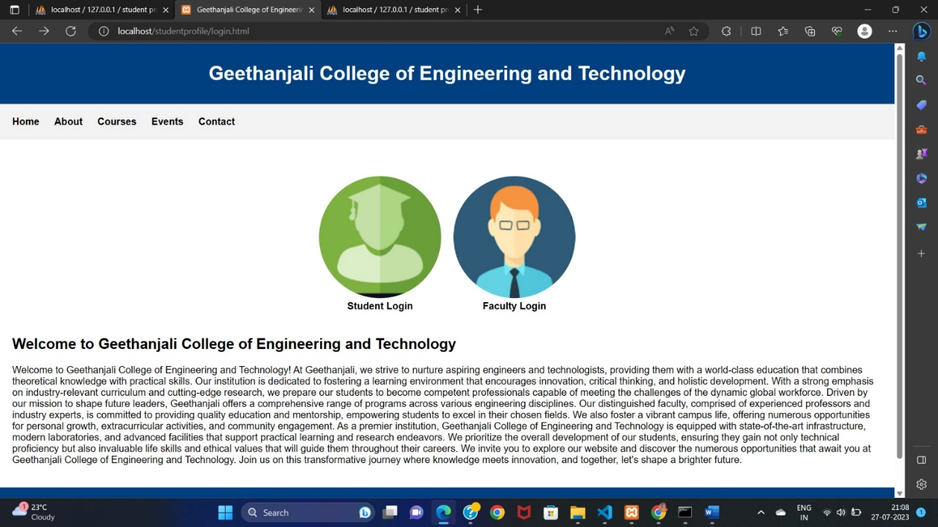

**Fig.1**

In fig.1 , we have the opening web page of our project. It contains basic details of Geethanjali college . It also contains student and faculty login options ,which take us to different login pages.

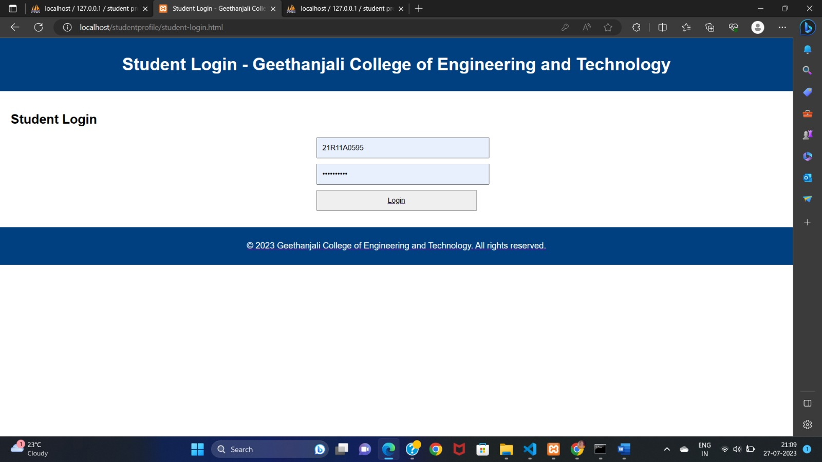

**Fig.2**

In fig.2, we have the student login page . The student should enter their user name and password to login. After logging in, we redirect to another web page.

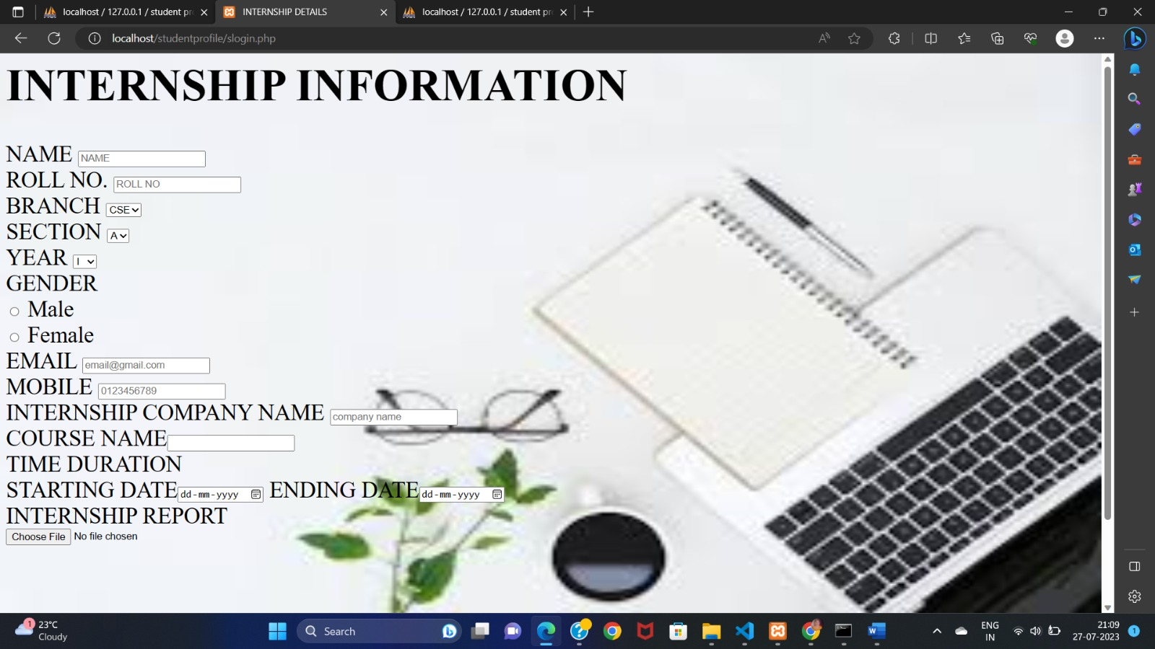

**Fig.3**

In fig.3, we have a registration form regarding all the details of the internship. These details are to be filled by the students.

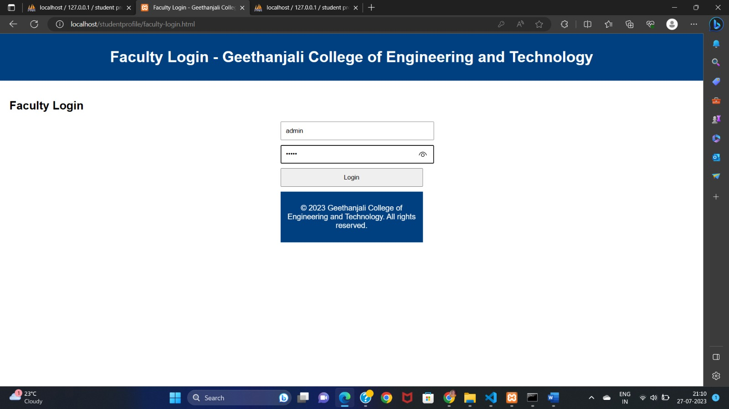

**Fig.4**

In fig.4, we faculty login page, the faculty has to enter their username and password to login . after login the page is redirected.

**6. OUTPUT**

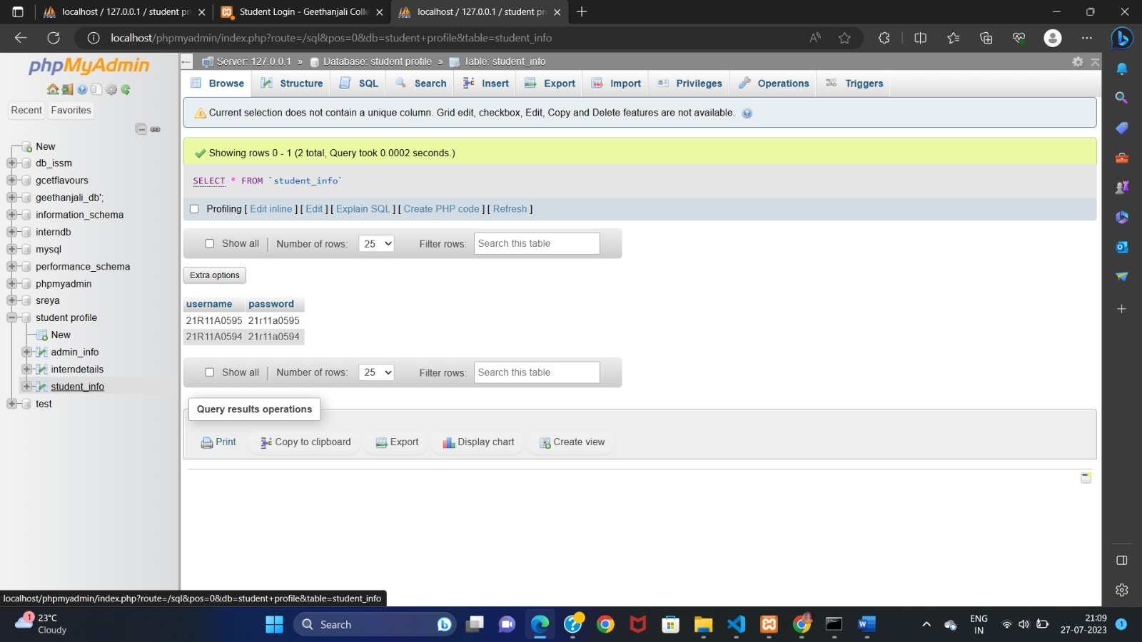**Fig.5**

In fig.5, we have the output of the student login. The login information of the student can be seen.

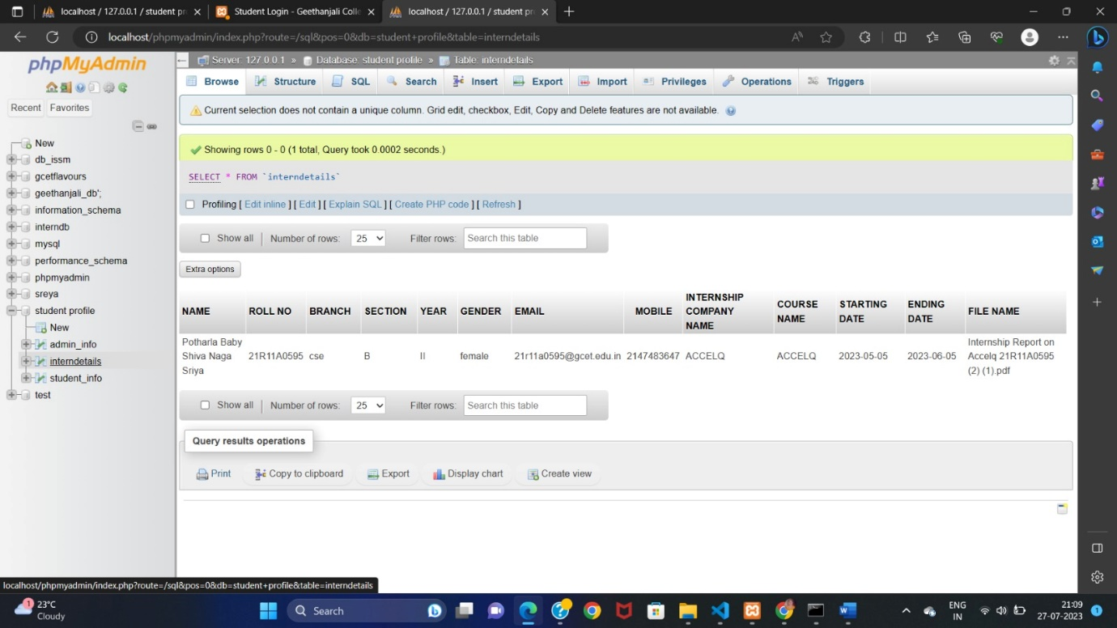

**Fig.6**

In fig.6 , we have the output of the internship information page. It is the information entered by the students regarding their internships.

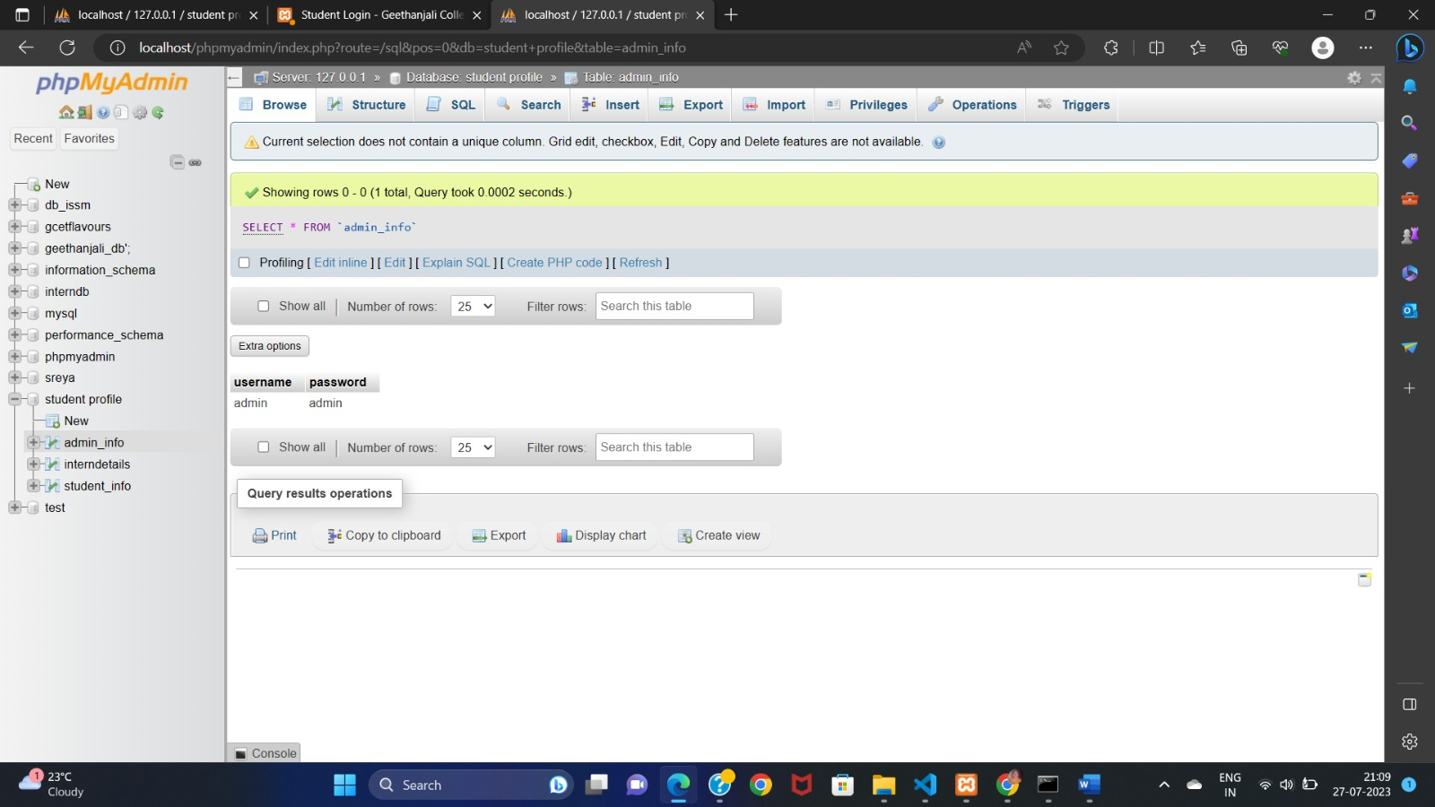

**Fig.7**

In fig.7, we have the out of the faculty login page. It is the credentials of the faculty.

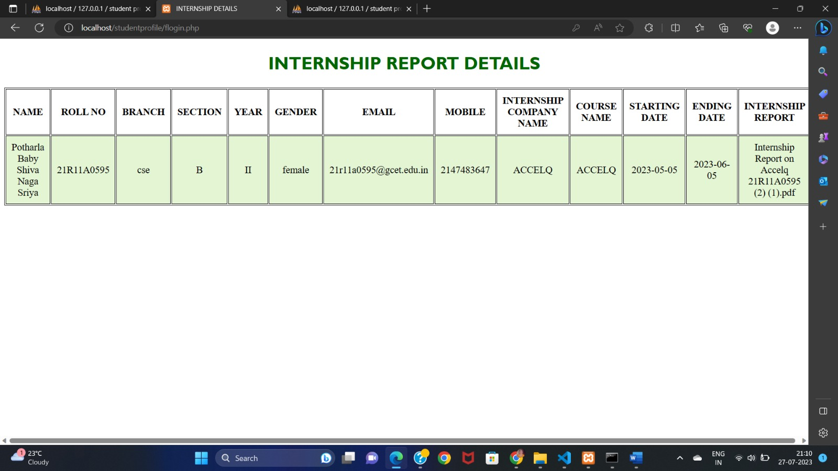

**Fig.8**

In fig.8 , we have the output of the faculty login page. After the faculty login, they can see the details regarding the internship of all the students. All the details are displayed in a tabular format.

**7. CONCLUSION**

The Web Application for Internship Details offers a comprehensive solution to the complex task of overseeing and coordinating internship programs. With a focus on efficiency, transparency, and simplified administration, this application eases the burden on educational institution and students alike . By streamlining document management and progress tracking, it contributes to the success of internship programs.

This user-friendly application is a valuable tool for all the people involved in the internship process, both the students and faculty. It not only simplifies the management of internship details but also enriches the overall internship experience for students and facilitates the work of educational institutions. It is an easy to use application for everyone involved and makes the process streamlined and easy maintenance.

**8. REFERENCES**

* www.google.com
* [www.geeksforgeeks.com](http://www.geeksforgeeks.com)
* [www.github.com](http://www.github.com)
* [www.wikipedia.com](http://www.wikipedia.com)
* [www.youtube.com](http://www.youtube.com)